I prefer: ORAL/ POSTER presentation (non-preferred should be deleted)
Title of abstract in Times New Roman, font: size 12 point, centred paragraph

First Author A.A¹, Second Author B.B ²,Third Author C.C³
¹Institution, Faculty, Department
²Institution, Faculty, Department
³Institution, Faculty, Department

The main text, like the author names used Times New Roman font, 12 point for the Author names and 11 point for the remainder of the abstract. The name of the person who will present the abstract should be underlined. Use 1.5 line spacing and leave a line gap between paragraphs. Type or paste your text into this file, but remember to keep the page margins the same as is set here which is 2.0 cm all round. Paragraphs are justified (straight-edged) on both left and right. The brief summary of the work should feature a summary. Abstracts should be written in English with a minimum of 250 and a maximum of 300 words. The limit for your abstract is one page. The title and authors of the study should be arranged by adding them to their places in the parts given in the example. At least 3 keywords must be added. If you would like to insert a figure you can do so. Use the insert picture command and paste special as an enhanced metafile for ease of handling. If you want, you can set the text to flow around the figure, but do remember to include a figure caption.

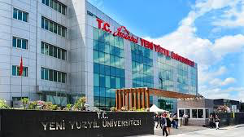
Figure: Figure Caption in here

Keywords: Aaaa, Bbbb, Ccccc, .....

Corresponding Author Contact: abcde@abcde.edu.tr

